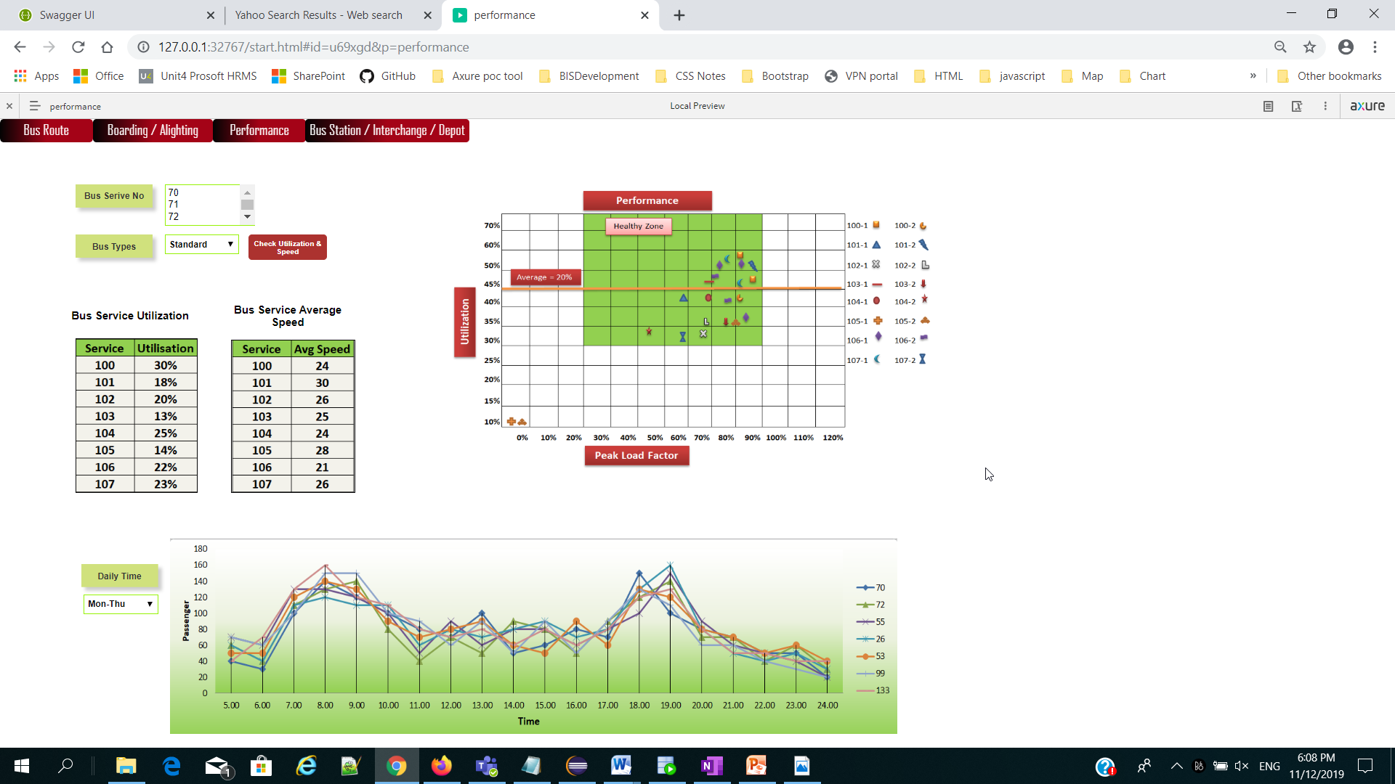

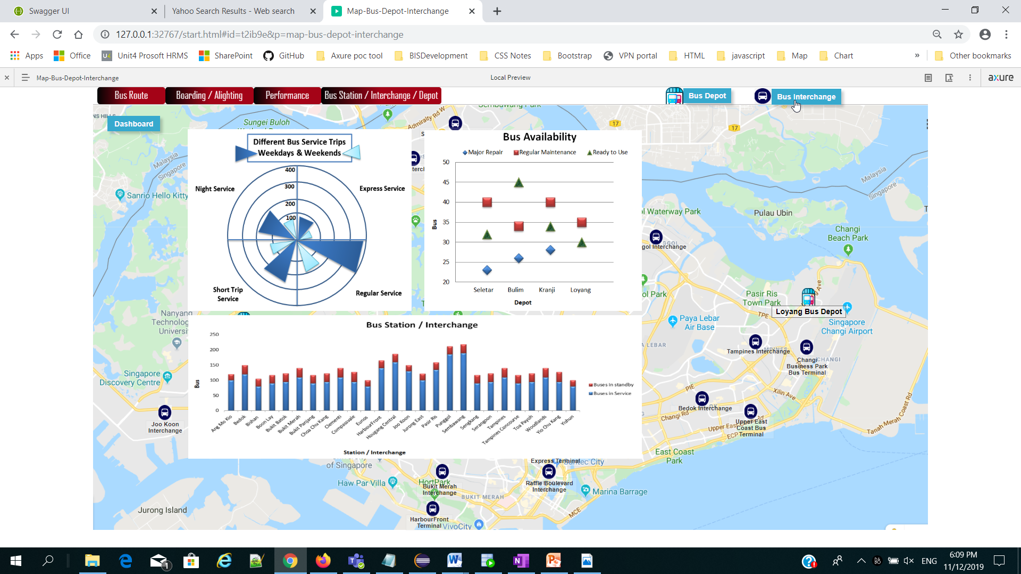

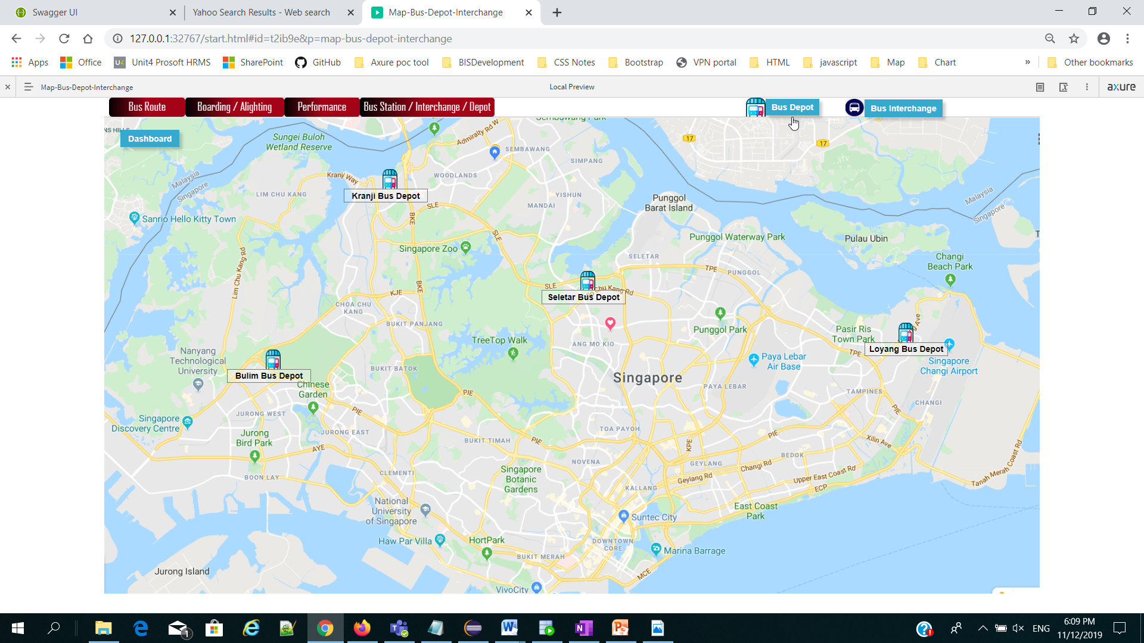



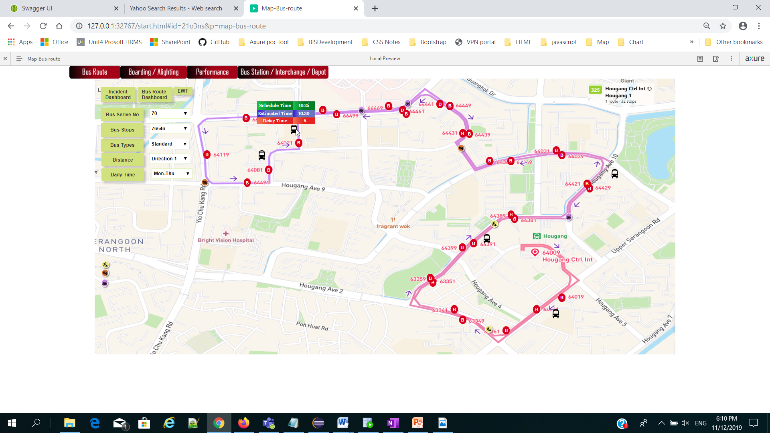

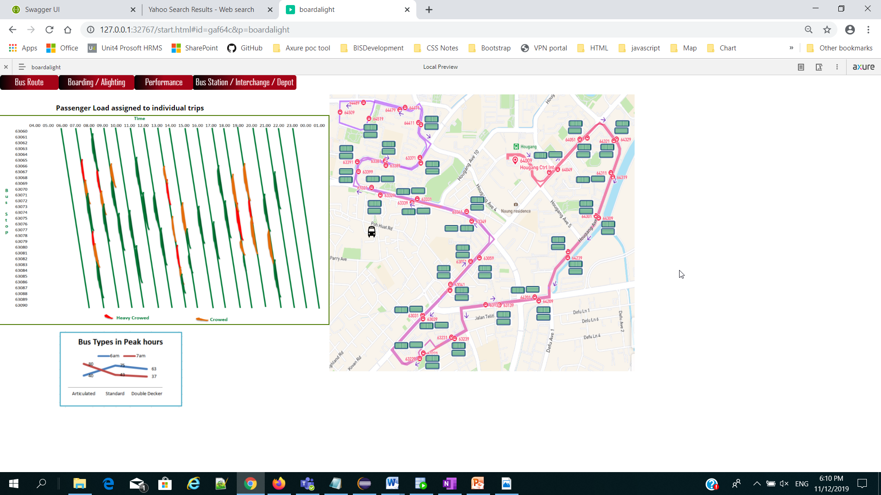

The chart represents bus service trips in weekdays and weekends.

There are 4 service trips.

The dark blue triangle shows the weekdays trips and light blue triangle shows the trips in weekends.

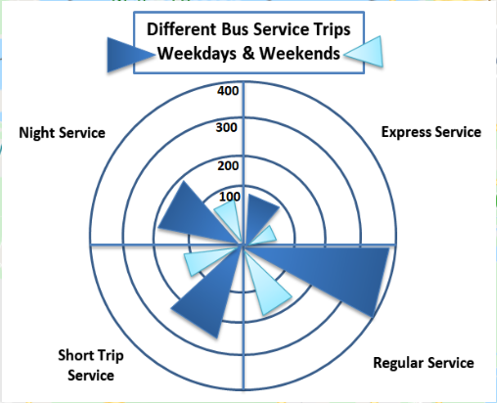

The chart represents bus availability information in Depot.

Each depot has different no. of bus in different condition.

There are 3 major conditions.

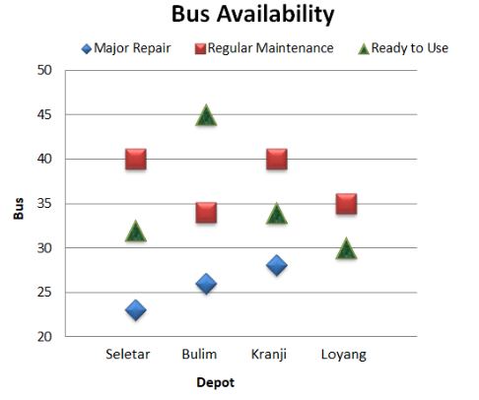

The chart represents bus availability information in the Bus Station and Interchange.

Buses in service and standby bus list here.

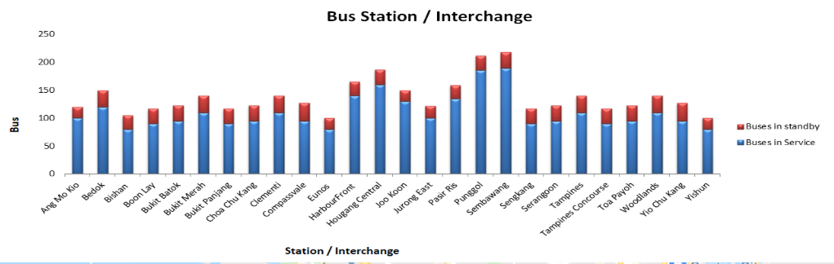

Utilisation, Peak Load Factor & Speed

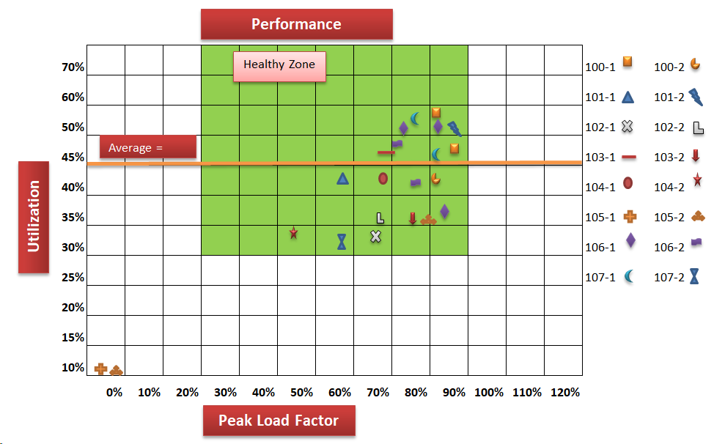

24-hour Runtime Profiling

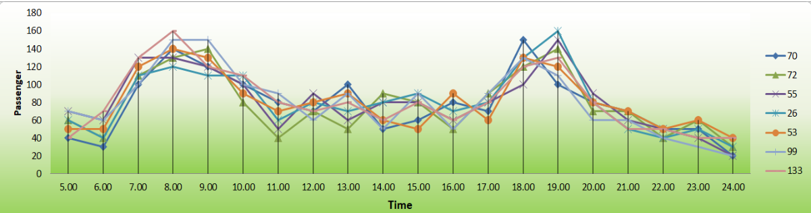

Passenger load assigned to individual trips in graphic timetables;

